**Leader Overview**



**Volume Overview**

**Believe Boldly**

*The gospel message is shocking to many, shocking because of its implications. God has made himself known to us and promised to place His Spirit into our heart. We have been given direct access to Him. The Bible encourages us to come to Him with boldness. Our boldness in approaching Him is not from our words or our achievements. Instead, it’s based on God’s promises. So we ask, remembering His power and faithfulness. And we encourage those around us to do the same. Believe boldly.*

**Session Overview**

**Encourage Others**

*In this* **Live** *session, kids will discover that they can have faith that God is working in other people’s lives, not just their own. After our initial internal response to Jesus, believers are called to use the change we’ve experienced to make a difference for others. The faith of four men on behalf of their paralyzed friend is a great example of how much we can do to connect people with Jesus.*

**Bible Lesson**

Four Friends’ Enormous Faith Moves Jesus to Heal Their Friend

[Mark 2:1–12](https://ref.ly/logosref/Bible.Mk2.1-12)

**Faith Fact**

I can have faith for others.

**Faith Verse**

[1 Corinthians 16:13–14](https://ref.ly/logosref/Bible.1Co16.13-14) (NLT)

Be on guard. Stand firm in the faith. Be courageous. Be strong. And do everything with love.

**Preparing for the Session**

**Leader Preparation Time: 20–25 Minutes**

|  |
| --- |
| ***You Will Need***  ***Large Group***   * *Bible* * *Worship songs (Song suggestions: “Nothing Is Impossible” Lyric Video by Planetshakers; “10,000 Armies” by Influence Music; “Way Maker” Lyric Video by Leeland; “Do It Again” by Elevation Worship)* * *For groups not using a phone or tablet only, add:*   *• Projector or TV*  *• Laptop*  *•* ***Faith Fact Slide***  ***• Faith Verse Video or Slide***  ***• Bible Lesson Video***  ***• Teaching Point Slides 1–3***   * *Rope for tug-of-war* * *Bandana or cloth to mark middle of rope* * *Painter’s tape*   ***Small Group***   * *Disposable plastic cups, three or more per group* * *Rubber bands, one per group* * *String* * *Scissors* * *Bibles for kids in the group to share* * ***Small Group Activity Page****, one per kid* * *Pencils or pens, one per kid* * *Crayons or markers*   *To access session content and videos from a computer, visit:* [*BibleEngagementProject.com/downloads*](https://bibleengagementproject.com/downloads) |
| ***Getting Ready***  ***Large Group***   * *Download videos and slides if needed.* * *Select worship song(s) and have them ready to play.* * *Read the Bible Lesson Scripture to prepare for Teaching Time.* * *Tape a line for each team that the rope’s center marker must cross for the team to win.*   ***Small Group***   * *Cut pieces of string about 2–3 feet in length, one per kid.* * *Tie strings evenly around each group’s rubber band.* * *Print copies of the* ***Small Group Activity Page****, one per kid.*   *First time leading* Live *for Kids? Check out the* [*Facilitator Guide*](https://0b769b0ed3569ef9d18b-f88d8272f61086866d50d048b43ef630.ssl.cf2.rackcdn.com/sites/biblengagementproject/Listen_Facilitator_Guide.pdf)*.* |

**Large Group**

**30 Minutes**

*See what’s needed at the beginning of the session.*

**Introduction**

Hey, everybody! I’m so excited that we get to spend time together today. Throw your hands in the air if you’re excited to be here! *(Group response)* Today we’re talking more about the way God can help us to be brave, strong, and bold no matter what we face. *(Hold up the Bible.)*

On the count of three, shout out the name of one of your really close friends. One, two, three. *(Group response)* That’s awesome! Sounds like you have some pretty great friends. Raise your hand if you’d help your friend with anything they needed. *(Group response)* Sounds like you are great friends too!

Having friends to encourage and support us is really important. Friends are a huge blessing. If our friends follow Jesus and know about God’s love, we can encourage each other to honor God. Part of being a good friend is helping and praying for our friends when they need extra support.

**Faith Fact**

That reminds me of our Faith Fact: **I can have faith for others.** In our Bible story, we’re going to see how a few friends worked extra hard to get their friend the help he needed.

• *Show the* ***Faith Fact Slide.***

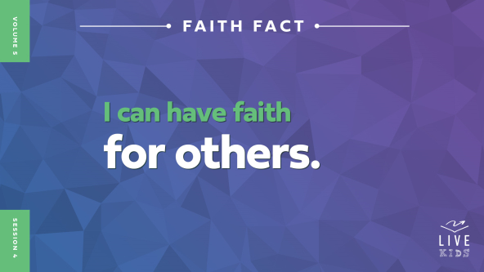

Sometimes it can be hard to trust God in our own life. So what does it mean to have faith for others? *(Allow responses.)* Having faith for others starts when we believe in God and trust God’s Word. Then we have the confidence to know God will take care of us when we’re in need—and He’ll do the same for our friends. When we go through hard times, we need to remind each other that God is good and He will keep His promises.

Let’s find out how to be the kind of friend who reminds others that God loves them. It’s so awesome that we have the power to encourage our friends and even have faith for them! Everyone, point at yourself and say, **I can have faith for others.** One more time: **I can have faith for others.** Well done!

**Game**

**Tug-of-War**

There’s a saying that goes, “Teamwork makes the dream work.” Today, our dream is simple: Win the game we’re about to play! Give me a thumbs-up if you’ve ever played tug-of-war. *(Group response)*

Here’s how the game works: We’ll have two teams of five people compete. When I tell you to pull, you’ll pull the rope toward your team’s side. The goal is to bring the center of the rope across your team’s line.

• *Consider the following examples when creating your own exciting matchups. (Use your discretion based on the kids in your group.)*

• *Boys vs. girls*

• *Fifth grade vs. fourth grade*

• *Leaders vs. kids*

• *Make sure kids are holding the rope and tugging safely throughout the game.*

• *The rope will be used later in Teaching Time.*

Great teamwork, everyone! Playing a game like tug-of-war is tough, and you absolutely can’t win by yourself. You need a team to gain the victory. And even when you have a team, sometimes you need to encourage each other. Raise your hand if you heard any of the players saying things like, “Everybody, pull!” or “We can do it!” *(Group response)*

When you cheer on your teammates, you’re showing that you have faith your team could win—even if that doesn’t happen in the end. Our Bible story is about five friends. *(Hold up your thumb.)* One of them was paralyzed—which means he couldn’t walk—and he needed help. *(Hold up the other four fingers on the same hand.)* And the other four worked together and found a way to get him that help. They had big faith for their friend. That reminds me of our Faith Fact. Let’s say it together: **I can have faith for others.**

**Worship**

Worshipping God builds our faith! Did you know that when you worship God, it can build up other people’s faith too? It’s true. Maybe you’re singing, raising your hands, or closing your eyes to focus on God. And when other people see you worshipping, it might make them want to worship God too! So who’s ready to worship God with me today? *(Group response)* One way to worship God is by singing. Let’s worship Him together.

• *Lead the kids in singing one or two praise songs. See suggestions at the beginning of the session.*

**Bible Lesson**

I’m so glad you sang and worshipped God with me! Remember, worship encourages you and other people. Plus, it builds your faith that God is working in your life and in other people’s lives too. Let’s pray and ask God to help us learn more from His Word today.

**Prayer**

|  |
| --- |
| *Dear God, thank You for this time to learn more about You. Help us believe in You, so we can help others experience Your love and power too. In Jesus’ name. Amen.* |

**Video Intro**

Remember our Faith Fact? Say it with me. **I can have faith for others*.*** Before we find out what the Bible says about this, let’s watch this video and check in with Dash.

• *Play* ***Bible Lesson Video****.*

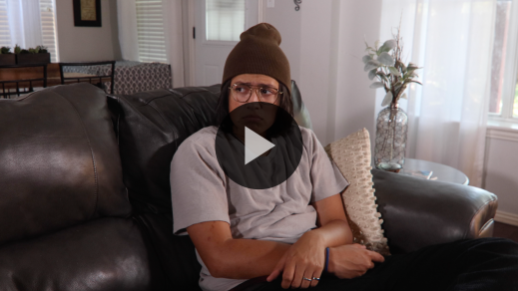

**Bible Story**

**Four Friends’ Enormous Faith Moves Jesus to Heal Their Friend**

Wow! I love that story. Have you ever wanted to encourage and help a friend who was going through a hard time? Dash told us about a Bible story where that happened, but let’s take a closer look.

**Teaching Time**

Jesus was coming back to the town of Capernaum after preaching in some other towns nearby. A lot of people who lived in Capernaum knew Jesus could do miracles. So of course, they wanted to see Jesus and have their own life changed.

Let’s jump right into our story and find out what happened! Remember our Faith Fact? *(Group response)* Yes, that’s it. **I can have faith for others.** Let’s say it all together. **I can have faith for others.** I think we’re ready!

So grab your Bible or pull up a Bible app on your device. Turn to [Mark 2:1–12](https://ref.ly/logosref/Bible.Mk2.1-12).

• *In order to keep Large Group time moving along, we recommend that the leader reads the Scripture portions aloud.*

• *Optional: Remind the kids to mark this place with a bookmark, so they can read it on their own at home.*

**1. Many people came to see Jesus.**

• *Show the* ***Teaching Point 1 Slide.***



• *Read* [*Mark 2:1–3*](https://ref.ly/logosref/Bible.Mk2.1-3)*.*

Wow! So many people came to see Jesus that the house where He was staying was packed. There wasn’t room for anyone else to squeeze through the door. Why do you think the people wanted to be around Jesus so much? *(Allow responses.)* Maybe they needed to be healed. Maybe they wanted to hear Jesus’ teaching. Maybe they were trying to figure out what made Jesus special. Some of them may have even been spying on Jesus to see if He was causing trouble. There were probably lots of different reasons people wanted to see Jesus.

How do you think it felt to be squished in the house with everyone else who wanted to see Jesus? *(Allow responses.)* It may have been a little uncomfortable, but Jesus probably loved it that people wanted to be near Him. After all, He came to earth so people could get close to God.

People gathered around Jesus because there was something special about Him. Most of them didn’t realize it yet, but He was God’s Son! Have you ever noticed a bunch of people crowding around one person who has a new toy or a something they got on their vacation? Imagine what would happen if your teacher brought her new puppy to school for a class pet. Everyone would be *swarming* around that puppy, trying to see it.

Jesus is way better than a toy or puppy, of course, but the situation is similar. So many people wanted to see Jesus and get close to Him that the house was totally full. The doorway was blocked. And for the friends of one paralyzed man, it was time to be creative.

**2. Four friends brought a paralyzed man to Jesus.**

• *Show the* ***Teaching Point 2 Slide.***

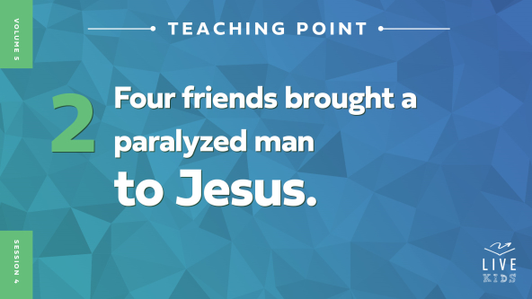

• *Read* [*Mark 2:4*](https://ref.ly/logosref/Bible.Mk2.4)*.*

Dug a hole? Through the roof? How does that even work? Well, houses in Bible times were different from the houses we’re used to. The roof was probably flat and made from wood and dried mud. It would’ve been pretty easy to dig a hole through it. But do you think the owner of the house was happy about the new hole in his roof*? (Group response)* Maybe not! But these men had decided that they were going to get their friend to Jesus! Why do you think it was so important to them? *(Allow responses.)*

The paralyzed man probably couldn’t have gotten to Jesus on his own, especially in such a big crowd. So the man’s friends decided to help him out. I need one volunteer to help me.

• *Hold the tug-of-war rope.*

• *Choose a smaller kid to be your helper.*

*(To volunteer)* Take one end of this rope, and I’m going to hold the other end. I want you to pull me ten feet across the room.

• *Do your best to resist being pulled.*

That’s hard to do by yourself, right? Okay, pick three friends to help you, and try again.

• *Put up a fight, but let the kids pull you ten feet.*

Great job! You can sit back down. It was much harder for one kid to pull me than for four kids to pull me, wasn’t it? *(Group response)* Here’s the thing: The paralyzed man needed his four friends to work together to carry him to Jesus. On top of their hard work, they also had faith that Jesus could heal their friend. I think that probably made it easier for the paralyzed man to believe that Jesus could heal him too!

I’m so glad the paralyzed man had friends with that much faith. We don’t know much about the man who couldn’t walk. Maybe he was excited to meet Jesus and had a ton of faith! Or maybe he had given up hope, and his friends said, “Please, let’s see if Jesus can help you!” Either way, his friends made a big difference in his life.

**3. Jesus healed the paralyzed man.**

• *Show the* ***Teaching Point 3 Slide.***



• *Read* [*Mark 2:5–12*](https://ref.ly/logosref/Bible.Mk2.5-12)*.*

Wow! Jesus healed the man who couldn’t walk! Honestly, this isn’t even a surprise to us. We know Jesus often healed people in the Bible. How awesome is it that people’s lives change so much when they meet Jesus! But there’s a little more to this story that we should notice.

Before healing the man, Jesus forgave his sins. This was a very unusual and surprising thing for Jesus to say. The religious leaders knew that forgiving sins was something only God could do. Most of them didn’t like what Jesus said because they didn’t understand Jesus was God.

But the man’s friends had faith in Jesus. The Bible even says that Jesus noticed their faith, and it was part of why the man was forgiven and healed. How amazing! This means that it makes a difference when we have faith for others to experience miracles and be healed! How do you think the man was feeling about his friends that day? *(Allow responses.)*

It’s awesome that the man’s friends got to be part of his miracle. All they really did was bring their friend to Jesus and have faith. Jesus was the One who actually healed him. But their small part made a big difference. Once he was in the room with Jesus, the man’s life was never the same. I hope his friends realized the difference their faith made.

Remember our Faith Fact: **I can have faith for others**. You and I can make a difference in our friends’ lives too. All we need to do is introduce them to Jesus and believe He can change their life.

**Prayer and Response**

*Consider playing a worship song softly in the background while kids pray.*

The four friends showed us what it means to have faith for someone else. We’re called to do the same thing. This could mean praying for someone in need or bringing them to church so they can hear about Jesus.

Before we pray, let’s think about this question: Who is one person in your life that God wants you to have faith for? Maybe that person needs to meet with Jesus in a special way. Maybe they need God’s peace. Maybe they need a miracle. Maybe they need to decide to follow Jesus and give their life to Him.

Let’s take some time to quietly think about our answer to that question: Who is one person in your life that God wants you to have faith for? And then think about how you can help that person meet with Him.

After you know who you are going to pray for, find a leader or a friend to pray with. This will help the person’s name stay in your heart and mind.

**Prayer**

*Optional: Have the kids repeat phrases of the prayer after you.*

|  |
| --- |
| *Dear God, thank You for letting us be part of what You’re doing. We know our faith can make a big difference in the lives of people around us. Please give us the faith to bring other people to You. In Jesus’ name. Amen.* |

**Faith Verse**

Our Faith Verse is all about being bold and courageous, doing everything with love. This is a great reminder as we have faith for others.

• *Play* ***Faith Verse Video****.*

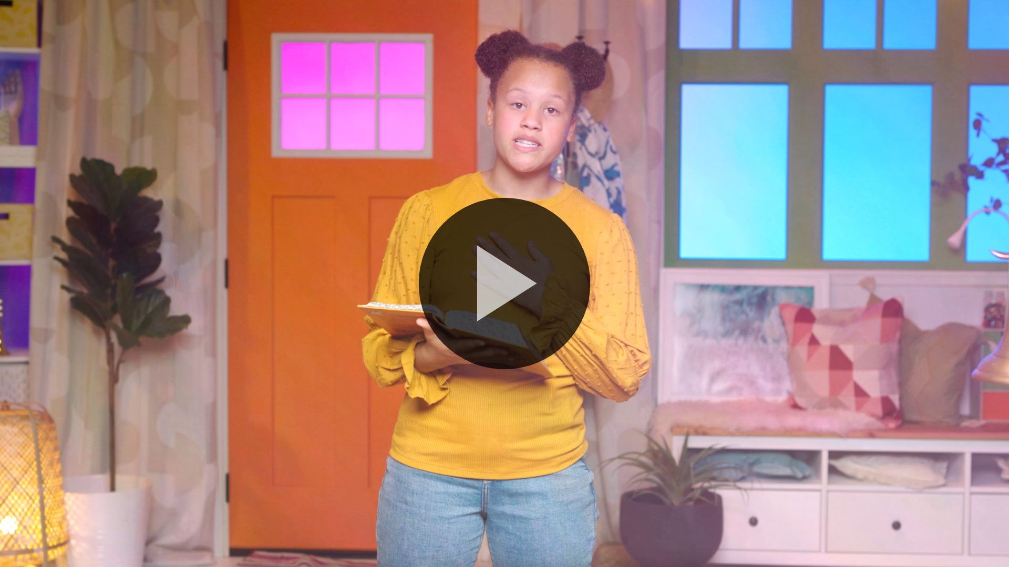

[1 Corinthians 16:13–14](https://ref.ly/logosref/Bible.1Co16.13-14) (NLT)

Be on guard. Stand firm in the faith. Be courageous. Be strong. And do everything with love.

Let’s say it as fast as we can. *(Group response)* Now let’s say it as slowly as we can. *(Group response)* Great job, everyone!

**Faith Fact**

Before we move on, let’s review our Faith Fact again. **I can have faith for others.**

• *Show the* ***Faith Fact Slide****.*



Point to yourself, and let’s say it again. **I can have faith for others.**

• *Dismiss kids to Small Group time or to go home if your group time ends here.*

**Small Group**

**30 Minutes**

*This section can be done in conjunction with the large group or on its own if you do small groups with your kids. During Small Group time, the goal is to connect the kids with the Word of God and to each other. All activities are led by the small group leader.*

**Group Connection**

**Rubber Band Lifters**

|  |
| --- |
| ***You Will Need***   * *Disposable plastic cups, three or more per group* * *Rubber bands, one per group* * *String* * *Scissors*   ***Getting Ready***   * *Cut pieces of string about 2–3 feet in length, one per kid.* * *Tie strings evenly around each group’s rubber band.* |

Our Bible story was about four friends who worked together to bring another friend to Jesus. Then Jesus changed that man’s life forever.

Let’s do something that takes a lot of teamwork! Here’s how it works. Our rubber band has a bunch of strings tied to it. Each of you will grab a string. You’ll work together as a team to open and close the rubber band around some cups to try and build a pyramid. You’re going to need some amazing teamwork, just like the man’s friends in our story.

• *Allow kids to do the activity. Assist as needed.*

Great job, everyone! Sometimes it can be challenging to work as a team. But when we do, we can accomplish great things.

**Bible Lesson Recap**

• *If small group activities are not immediately following large group time, you may want to read the Bible story passage before the discussion.*

|  |
| --- |
| ***You Will Need***   * *Bibles for kids in the group to share*   *No prep is needed for this activity.* |

**Bible Story Review: Four Friends’ Enormous Faith Moves Jesus to Heal Their Friend**[**Mark 2:1–12**](https://ref.ly/logosref/Bible.Mk2.1-12)

What was the most interesting thing about today’s Bible story? *(Allow responses.)* Those are great answers! Remember, lots of people were crowding around Jesus when He came back to the house in Capernaum where He was staying. Four men wanted to bring their paralyzed friend to Jesus, but they couldn’t find a way through the crowd, so they dug through the roof and lowered him inside the house! Jesus saw their faith and healed the man in front of everyone. Why do you think it was important that the friends had faith for the paralyzed man? *(Allow responses.)* Their faith led to his miracle. And our faith can lead to miracles for our friends too.

• *Optional: Give each kid a Bible and read the Bible story together.*

**Group Discussion**

*Feel free to use all or just a few questions as a jumping-off place for good discussion. Questions marked with * are designed for more conversation. Adjust the questions based on the age or maturity of your group. Typically, older kids will be able to dive a little deeper than younger ones.*

**Questions**

Why do you think such a large crowd gathered around Jesus?

* What do you think the crowd thought about Jesus?

How do you think the paralyzed man felt when he heard Jesus was in town?

* What kind of friends did the paralyzed man have? How do you know?

What would you think if you saw someone cutting a hole in the ceiling right now?

How was the paralyzed man different after meeting Jesus?

* How can you have faith for others?

* How does having faith for others make a difference in their lives?

* Who can you have faith for? And how are you going to show it?

**Live It**

**Faith Fact**

Our Faith Fact today is **I can have faith for others.** The paralyzed man had amazing friends who showed us one way to do that. Having faith for others can create a pathway for Jesus to change their life. When we introduce our friends to Jesus, He can heal their HPara if they’re sick. He can give them peace if they’re worried. Our friends can even say yes to believing in Jesus and then spend forever with Him. There is so much good that can happen when we have faith for others!

**Challenge**

This week’s challenge is to have faith for someone else. Maybe it’s a family member, a friend, or a neighbor. Ask God what you can do to help them meet Jesus. You could pray for them if they’re going through a hard time. You could invite them to church to hear about Jesus. Or you could tell them what Jesus has done for you. Pick one way and try it out this week. Let’s see what God will do!

**Prayer**

*Finish group discussion by sharing prayer requests and praise reports. Keep track of your small group’s prayer requests and review them each time you meet.*

• *Have kids share and pray for each other’s prayer requests.*

|  |
| --- |
| *Dear God, thank You for letting us bring people to You and be part of their miracles. Help us to boldly have faith for others. Help us believe that You will always be with us, so we don’t have to be afraid. In Jesus’ name, we pray. Amen.* |

**Faith Verse Review**

|  |
| --- |
| *No prep is needed for this activity.* |

Our Faith Verse is [1 Corinthians 16:13–14](https://ref.ly/logosref/Bible.1Co16.13-14). God wants us to be loving and look for ways we can have faith for other people. Let’s go over the Faith Verse together.

• *Show* ***Faith Verse Video****.*



[1 Corinthians 16:13–14](https://ref.ly/logosref/Bible.1Co16.13-14) (NLT)

Be on guard. Stand firm in the faith. Be courageous. Be strong. And do everything with love.

The people around us need to meet Jesus. We can be courageous and tell people about Jesus, because we know the difference He will make in their life! Let’s review our Faith Verse a few more times. Try to memorize it as best as you can because you will need to know it for the Faith Verse game.

• *Say the verse as a group a couple of times.*

**Faith Verse Fun**

**Act It Out**

All right, now it’s time to put our knowledge of the Faith Verse to the test. You’ll get into groups of two or three. And I’ll give you a few minutes to come up with a creative way to present the Faith Verse to the rest of us. You’re going to act out a situation where friends are helping someone. As a part of your drama, say the Faith Verse together. Are you ready to take on this challenge? *(Group response)*

• *Have the kids form groups of two or three and allow them to practice.*

• *Give time for each group to present their drama to the rest of the kids.*

• *Optional: Decide which group worked together the best and came up with the most creative situation to present the verse.*

I love seeing the creativity that happens when you work together. You did an amazing job presenting the verse creatively as a team. And memorizing this Faith Verse will help you have faith for others!

**Activity Page**

**Connect the Dots**

|  |
| --- |
| ***You Will Need***   * ***Small Group Activity Page****, one per kid* * *Pencils or pens, one per kid* * *Crayons or markers*   ***Getting Ready***   * *Print copies of the* ***Small Group Activity Page****, one per kid.* |

Our Faith Fact is **I can have faith for others.** Having faith for others means helping them connect with Jesus, just like the paralyzed man’s friends did for him.

• *Hand out a copy of the* ***Small Group******Activity Page,*** *a pencil, and crayons to each kid.*

Let’s connect the dots to see what’s missing in this picture from our Bible story. Then color the picture when you’re done.

• *Allow time for kids to finish their page.*

**Dismissal**

Remember, God wants us to be close to Him. When we follow Jesus and obey God’s Word, we realize how much other people need Him too! Let’s pray.

**Prayer**

|  |
| --- |
| *Dear God, please help us lead others to You. We know how amazing You are. We want others to know it too. Help us to have faith that You will work powerfully in other people’s lives. And use us to be a part of what You want to do for others. In Jesus’ name. Amen.* |

**Faith Fact Recap**

• *Show the* ***Faith Fact Slide****.*



Remember, God doesn’t just want *me* or someone *else* to have bold faith. He wants *you* to believe in Him too! One way to grow strong in our faith is to live out our Faith Fact. Let’s say it together! **I can have faith for others.** I’m so glad you came today. I can’t wait to see you next time**.**

• *Send home the* ***Small Group******Activity Page.***

• *Remind parents that there are* ***Family Devotions*** *available on the app to do with their kid.*

• *Tell everyone the date and time for the next session.*